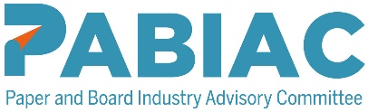

Briefing document for employees completing the questionnaire

Health and Safety Climate Opinion Survey

Name of employer (Optional) ………………………….

Dear Employee,

The attached health and safety opinion survey questionnaire has been introduced as a way of allowing you to tell the company what you all actually think of the health and safety standards on your site.

The survey has the full support of [insert name of appropriate senior manager or executive] and has the full backing of the trade union / employee safety representatives / site safety committee [you need to tailor the wording to suit your circumstance].

Please take the time to complete this questionnaire and tell us what you think. We will summarise your collective responses, let you know the results and use them to improve health and safety standards.

Please circle your shift / work discipline at the bottom of the questionnaire and then tick the appropriate box to indicate whether you either agree, mostly agree, mostly disagree or disagree with each statement made.

If you have any questions, please check with the person responsible for carrying out this survey at your site. Once completed, hand the form to them.

Remember that the survey is anonymous, and you should not put your name on the questionnaire unless you want to.

We shall conduct a further survey in the future to see what progress has been made in improving standards and your perception of health and safety.

Thank you for your co-operation.

Regards

Signed

Position

